**Deploying Recuritment and Onboarding on AWS S3 Bucket Using HTML Code**

This document provides step-by-step instructions for deploying HTML file on an Amazon S3 bucket, enabling static website hosting, configuring necessary permissions, and website publicly accessible.

**1. Verify Application Locally:**

Before deploying our application to AWS, it is essential to test it locally to everything functions correctly.

Steps to verify locally:

1. Open the HTML file:
   * Open our HTML file directly in a web browser on our local machine.
   * If the application executes successfully, proceed to the next steps for deployment.

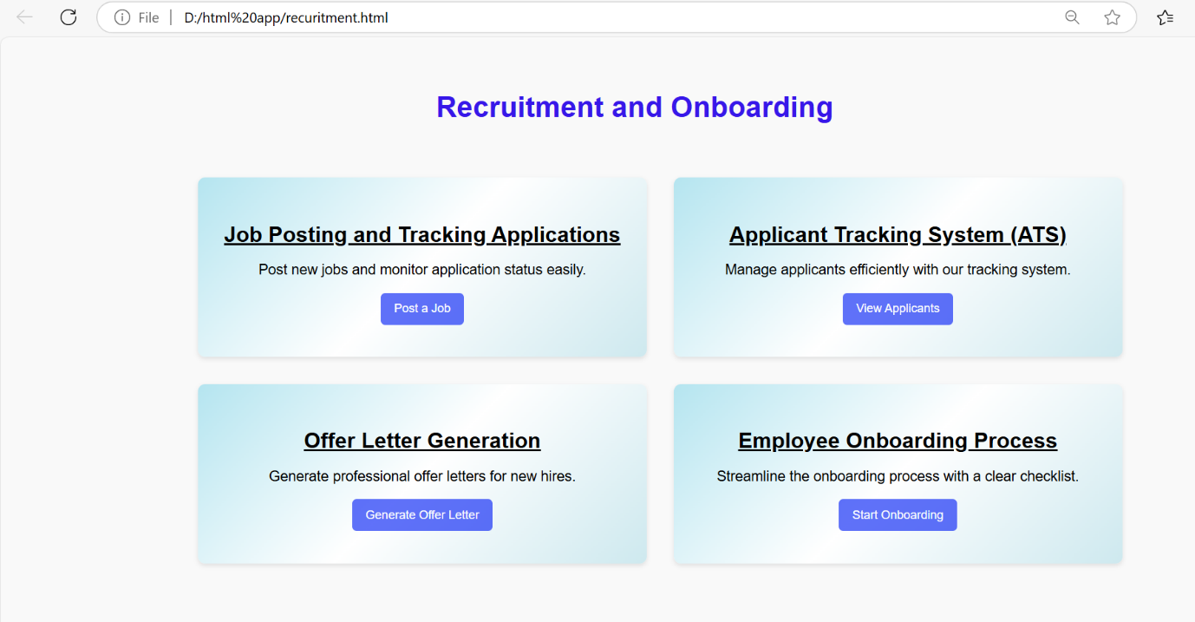

**Steps for Deploying HTML Code on AWS S3**

**1. Log in to AWS Console**

* Open the browser and navigate to the **AWS Management Console.**
* Sign in to our AWS account using our credentials (email id and password).
* Once logged in to AWS it shows AWS Dashboard.

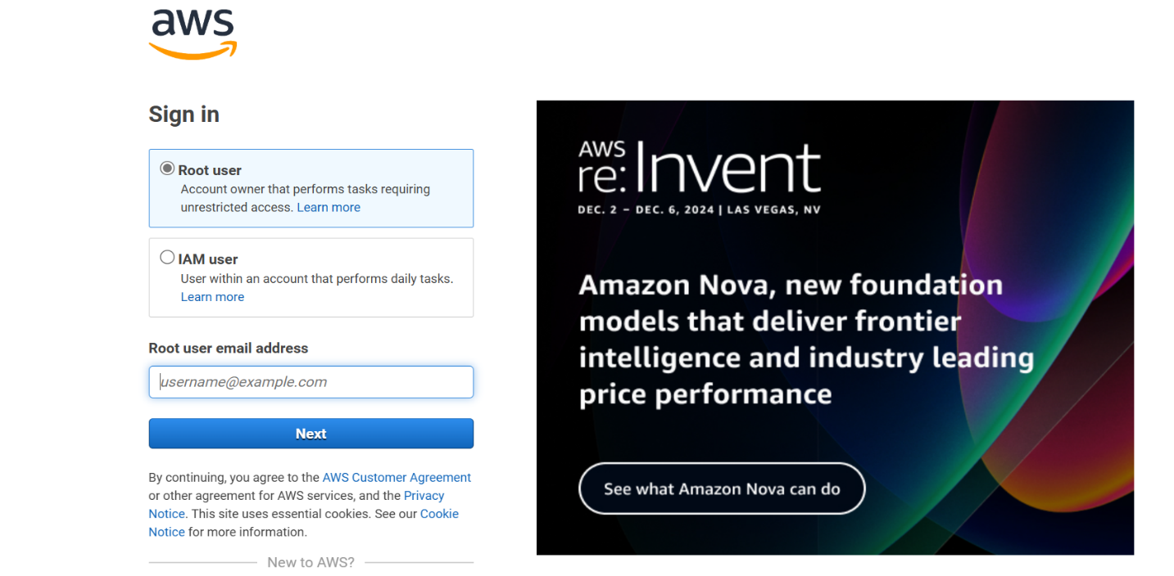

**2. Create a New S3 Bucket**

* From the AWS Dashboard, type S3 in the search bar and select S3 under the “Services” section.
* In the General Purpose buckets, click on the Create bucket button.Provide a unique name for our bucket( recruitment page or anyname).
* Select the AWS region we want to store the bucket. Click on Create bucket to create the new S3 bucket.

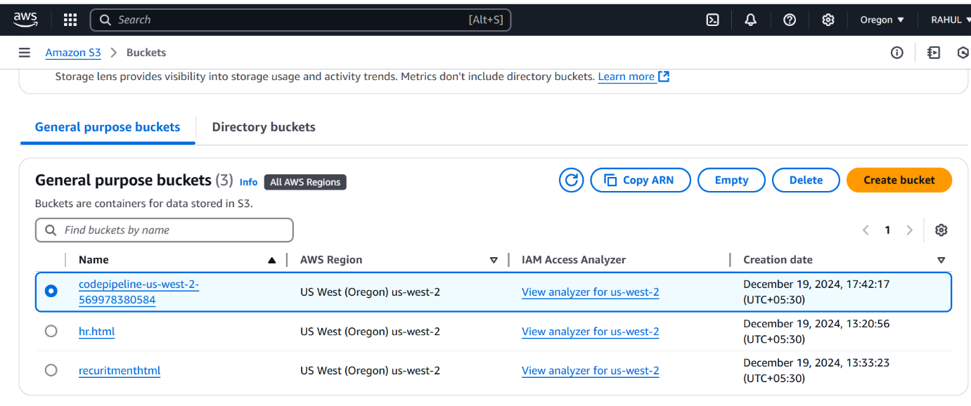

**3. Upload Files (HTML File)**

1. Once the bucket is created and enter in to Bucket Overview page. Inside the bucket, click on the Upload button and click Add files and Add folder to upload our HTML file.
2. After adding the files and folders, click on Upload to upload the files to our S3 bucket.

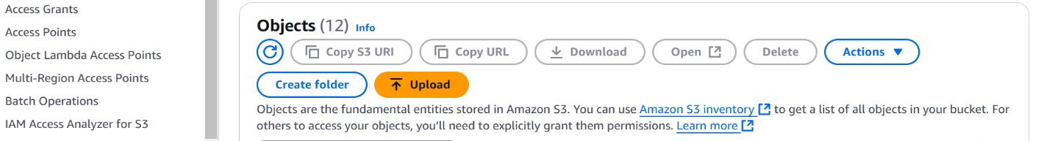

4.  **Static Website Hosting**

1. Go to the Properties tab within our S3 bucket. Scroll down to the Static website hosting section, Click Edit to enable static website hosting.
2. Select the option Enable and enter the name of our index document (recuritment.html).

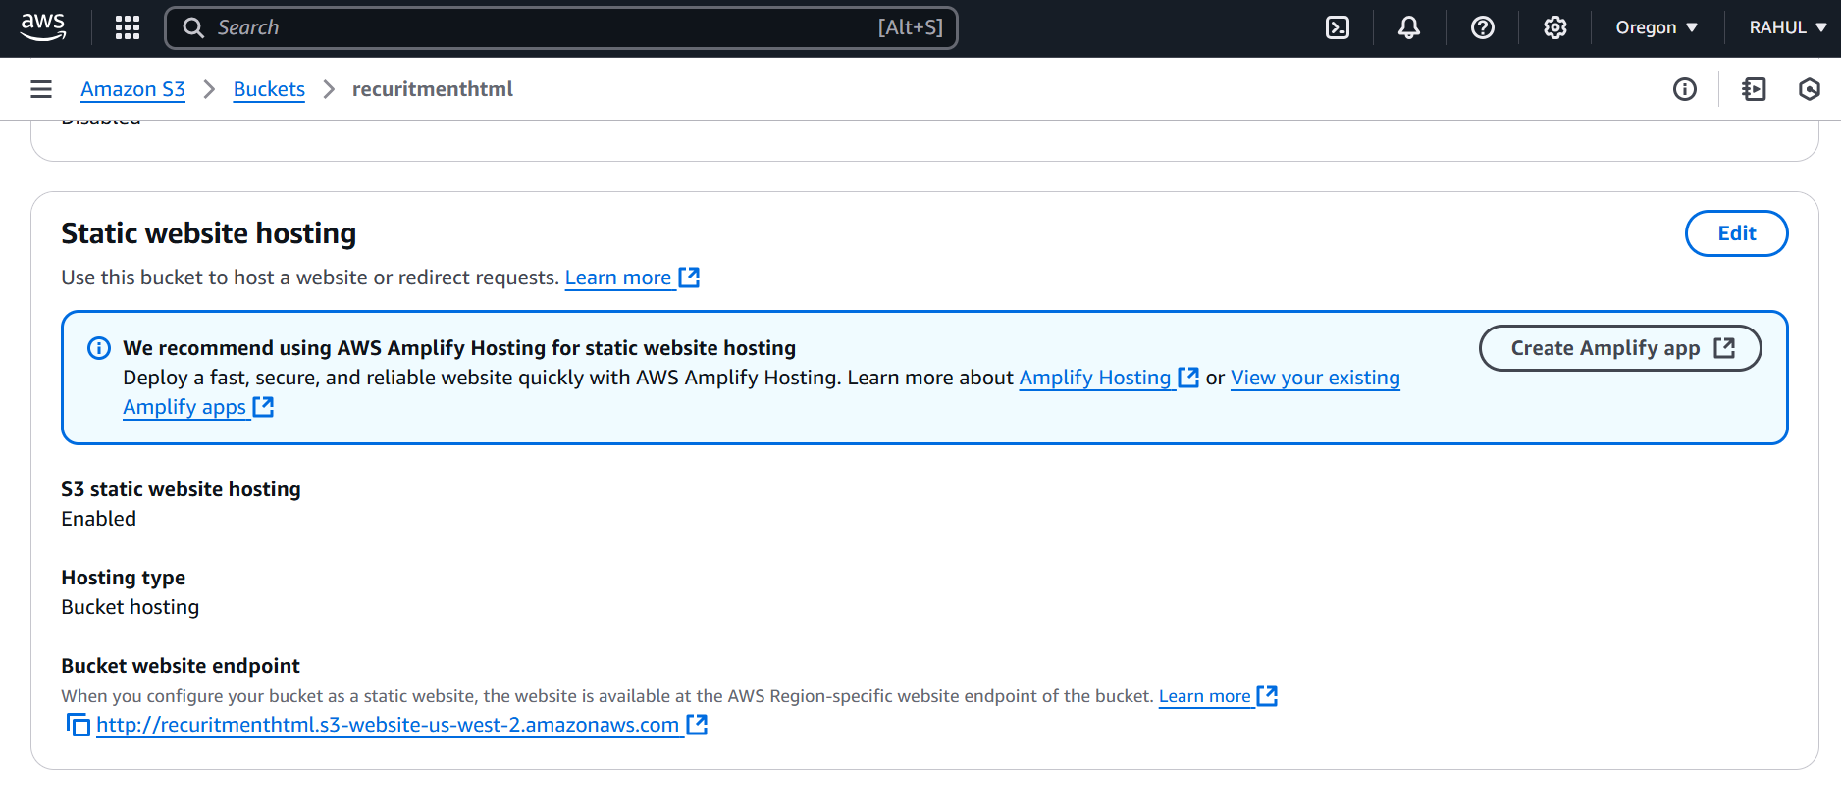

**5. Update Permissions for Public Access**

1. Click on the Permissions tab of our S3 bucket and open Block public access to Edit.
2. Uncheck the Block off public access box to disable public access restrictions.
3. After block off and Save changes.

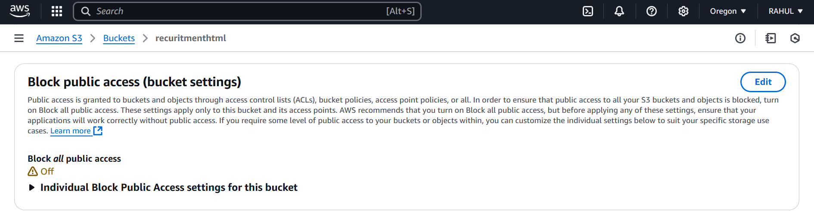

**6. Modify Object Ownership and Set ACLs**

1. In the Permissions tab, scroll down to the Object ownership and click on the edit change the ownership to ACLs enabled .
2. Click on Save changes.

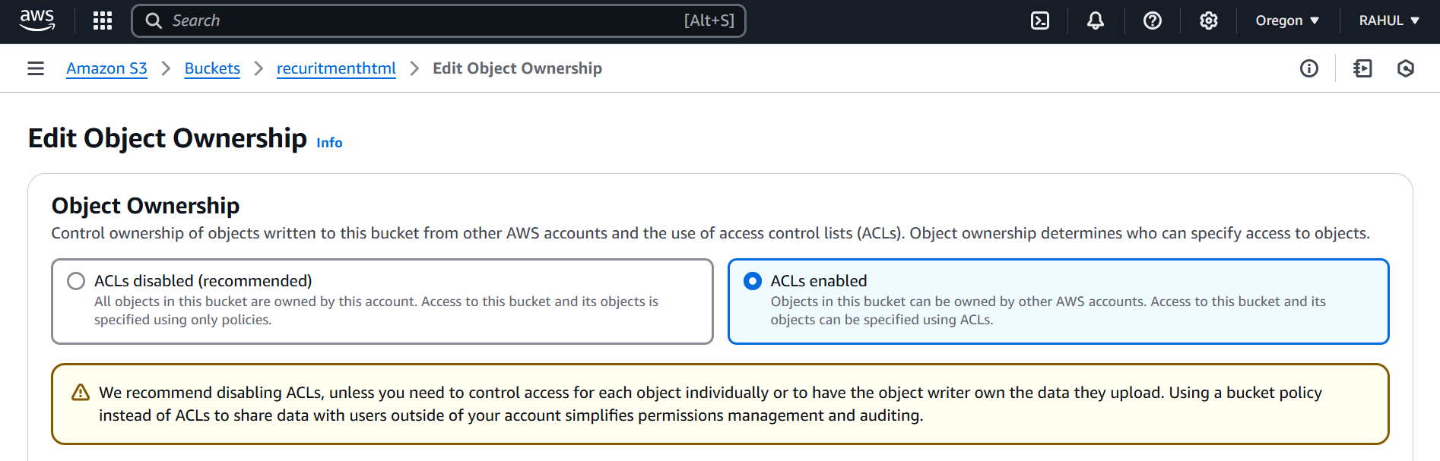

**7. Make Files Public Using ACL**

1. Go back to the Objects tab in our S3 bucket and select the file we want to make public (recuritment.html).
2. Click on Actions and select Make public using ACL , and click on the Make Public to access the file.

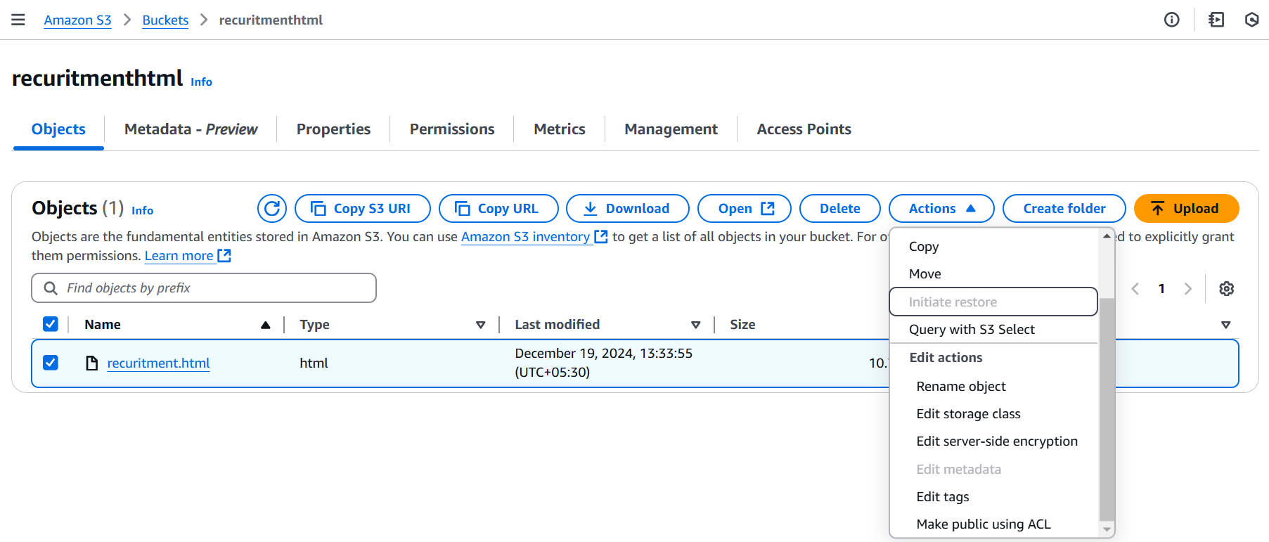

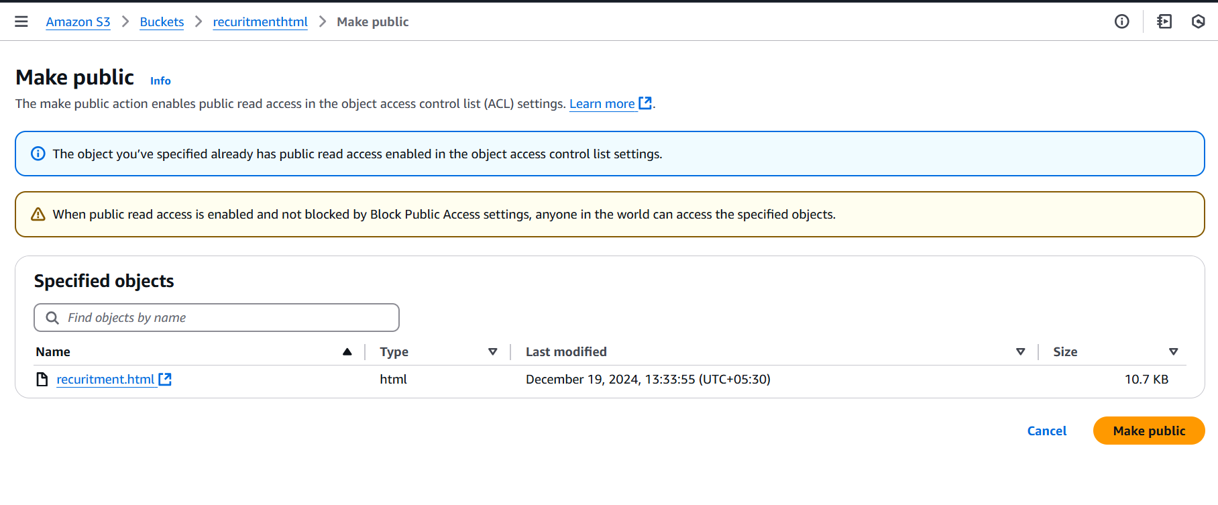

**8. Access the Website Using the Public URL**

1. Once the files are publicly accessible, go to the Properties tab in the bucket and Scroll down to the Static website hosting section and find the Endpoint URL.
2. Copy the URL

(**https://recuritmenthtml.s3.us-west-2.amazonaws.com/recuritment.html**).

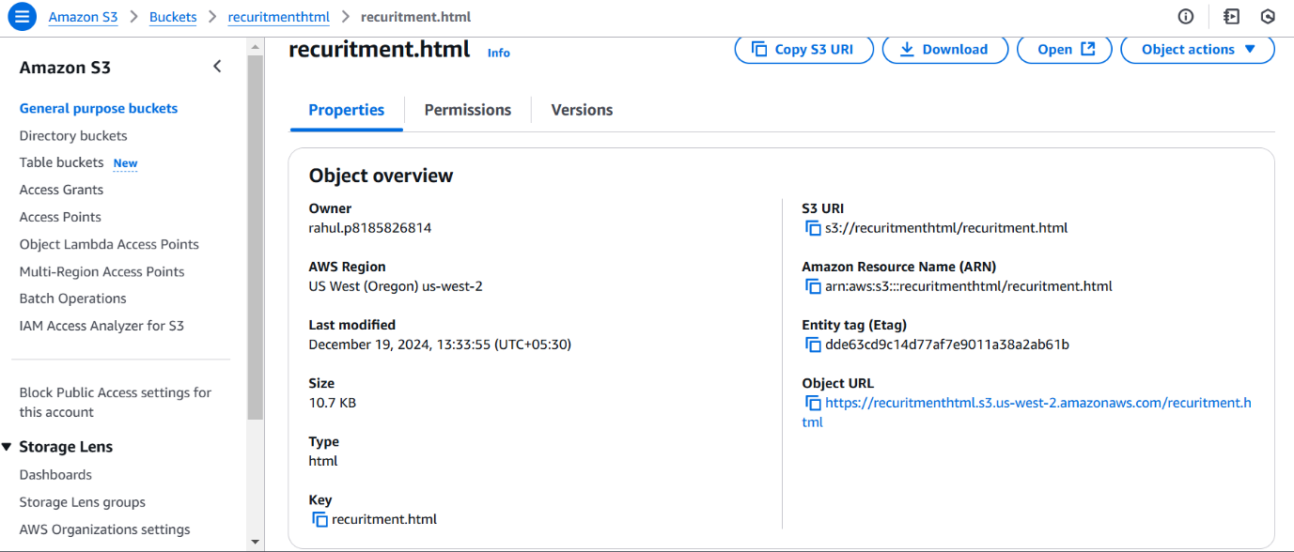

1. Open the URL in our browser to access our HTML website hosted on AWS S3.



* After hosting HTML website
* Job Posting and Tracking Applications click on Post a job details and the page it will shows
* 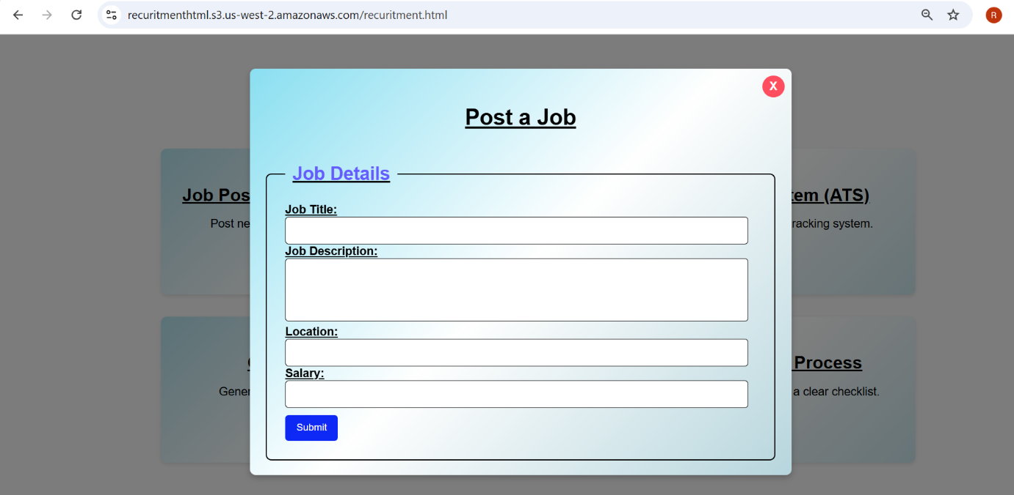
* On Applicant Tracking System click on the View applicants to watch the applicant information and the page will shows

